Lab 09 – Worksheet

Name: Faaz Shahab, Mohib Ul Mehdi, Basim Hussain | ID: fs09911, mm09730, mh09732 | Section: T2

Task 1
Main Control TT:
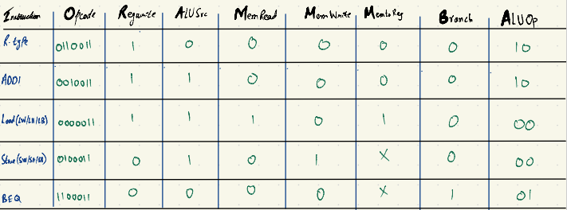

ALU Control TT:
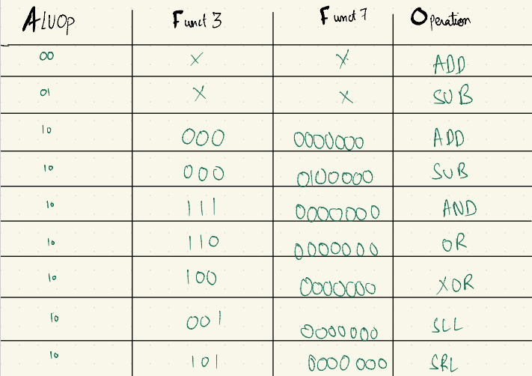

Task 2
Required Verilog Files attached in the folder uploaded in Github
Synthesis proof:

Simulation:
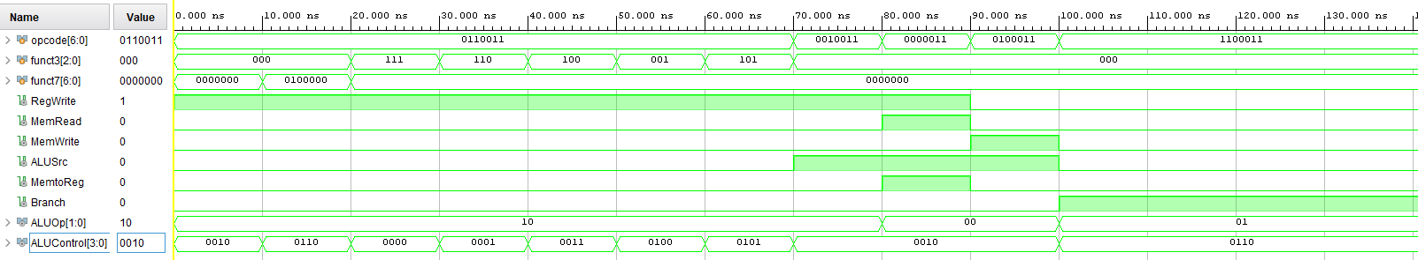

Task 3
Required Verilog Files attached in the folder uploaded in Github
Synthesis proof:

RTL Schematic:
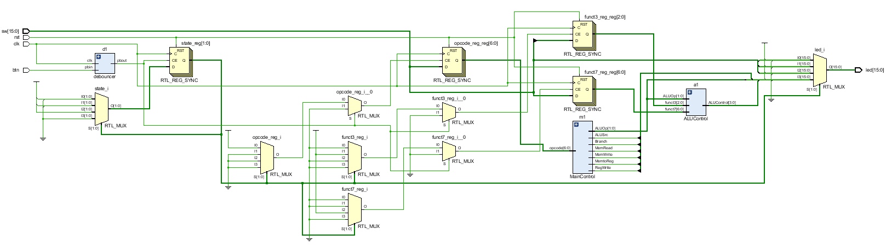

Assessment Rubric
Lab 09: Implementing Nested Procedures and Sorting

 | Task No. | LR 2  Code | LR 5  Results | LR 11 (Design)
In-Lab | Pre-Lab | - | /15 | -
 | Task 1 | - | - | /10
 | Task 2 | /20 | /20 | -
 | Task 3 | - | /15 | -
Total Points |  | /20 | /50 | /10
CLO Mapped |  | CLO 1

Affective Domain  Rubric |  | Points | CLO Mapped
AR7 | Report Submission & Git Upload | /10 & /10 | CLO 1

CLO | Total Points | Points Obtained
1 | 100
Total | 100

For description of different levels of the mapped rubrics, please refer to the Lab Evaluation Assessment Rubrics and Affective Domain Assessment Rubrics provided here.

Lab Evaluation Assessment Rubric
# | Assessment Elements | Level 1: Unsatisfactory | Level 2: Developing | Level 3: Good | Level 4: Exemplary
LR2 | Program/Co de/ Simulation Model/ Network Model | Program/code/simulation model/network model does not implement the required functionality and has several errors. The student is not able to utilize even the basic tools of the software. | Program/code/simulation model/network model has some errors and does not produce completely accurate results. Student has limited command on the basic tools of the software. | Program/code/simulation model/network model gives correct output but not efficiently implemented or implemented by computationally complex routine. | Program/code/simulation  /network model is efficiently implemented and gives correct output. Student has full command on the basic tools of the software.
LR5 | Results & Plots | Figures/ graphs / tables are not developed or are poorly constructed with erroneous results. Titles, captions, units are not mentioned.  Data is presented in an obscure manner. | Figures, graphs and tables are drawn but contain errors. Titles, captions, units are not accurate. Data presentation is not too clear. | All figures, graphs, tables are correctly drawn but contain minor errors or some of the details are missing. | Figures / graphs / tables are correctly drawn and appropriate titles/captions and proper units are mentioned. Data presentation is systematic.
AR9 | Report Content/Code Comments | No summary provided. The number/amount of tasks completed below the level of satisfaction and/or submitted late | Couldn’t provide good summary of in-lab tasks. Some major tasks were completed but not explained well.  Submission on time. Some major plots and figures provided | Good summary of In-lab tasks. All major tasks completed except few minor ones. The work is supported by some decent explanations, Submission on time, All necessary plots, and figures provided | Outstanding Summary of In-Lab tasks. All task completed and explained well, submitted on time, good presentation of plots and figure with proper label, titles and captions

